**Manual técnico**

**Descripción**: El siguiente manual consta de los pasos o requerimientos para que la aplicación de escritorio (PARSER-PY) funcione. Además presenta el diagrama de clases, diagrama de árbol, el diagrama de transiciones. Estos dos últimos diagramas están relacionados con la creación del autómata finito determinista usando el método del árbol.

**Instalaciones necesarias:**

1. Versión de java:

openjdk 17.0.8  
OpenJDK Runtime Environment (build 17.0.8+7-Ubuntu-120.04.2)   
OpenJDK 64-Bit Server VM (build 17.0.8+7-Ubuntu-120.04.2, mixed mode, sharing

1. Tener instalado Graphiz, versión recomendada(2.43.0):
   1. En windows, link de descarga; <https://graphviz.org/download/>
   2. En linux:
      1. Comando de instalación: sudo apt install graphviz o sudo apt-get install graphvi, link de referencia: <https://graphviz.org/download/>

**Puntos a tomar en cuenta:**

1. El ejecutable debe estar al mismo nivel de la carpeta src del código del proyecto principal.

**Expresiones regulares para los tokens:**

**Identificadores**:

([a-zA-z]|_)([a-zA-z]|_|[0-9])*$

([a-zA-z]+|\_)([a-zA-z]|\_|[0-9])*$

**Operadores**:

(+|-|**|/|//|%|*)$

**Comparación**:

(==|!=|>|<|>=|<=)$

**Asignación**:

(=)$

(=|+=|-=|**=|/=|//=|%=|*=)$

**Palabras clave/ true / false:**

[a-zA-Z]*

**Constantes**:

Entero:

[0-9]+

Decimal:

[0-9]+[.][0-9]+

Cadena:

(['])(.*)(['])$

(["])(.*)(["])$

**Comentario**:

[#](.)*$

. → cualquier símbolo del alfabeto.

**Otros**:

(\(|\)|\{|\}|\[|\]|\,|\;|\:)$

**Expresión regular general:**

([a-zA-z]|_)([a-zA-z]|_|[0-9])*|

(+|-|**|/|//|%|*)|

(==|!=|>|<|>=|<=)|

(=|+=|-=|**=|/=|//=|%=|*=)|

([a-zA-Z]*)|

([0-9]+)|

([0-9]+[.][0-9]+)|

(['])(.*)(['])|

(["])(.*)(["])|

([#](.)*)|

(\(|\)|\{|\}|\[|\]|\,|\;|\:)$

**Tabla de transiciones:**

|  |  |  |  |  |  |  |  |  |  |  |  |  |  |  |  |  |  |  |  |  |
| --- | --- | --- | --- | --- | --- | --- | --- | --- | --- | --- | --- | --- | --- | --- | --- | --- | --- | --- | --- | --- |
|  |  | 0 | 1 | 2 | 3 | 4 | 5 | 6 | 7 | 8 | 9 | 10 | 11 | 12 | 13 | 14 | 15 | 16 | 17 | 18 |
|  |  | **L** | **D** | _ | **+** | **-** | **\*** | **/** | **%** | **=** | **!** | **>** | **<** | **'** | **“** | **#** | **(** | **)** | **{** | **}** |
| 0 | s0 | **1** | **12** | **2** | **3** | **4** | **5** | **6** | **7** | **8** | **9** | **23** | **11** | **13** | **14** | **15** | **10** | **10** | **10** | **10** |
| 1 | s1 | **1** | **2** | **2** | **-1** | **-1** | **-1** | **-1** | **-1** | **-1** | **-1** | **-1** | **-1** | **-1** | **-1** | **-1** | **-1** | **-1** | **-1** | **-1** |
| 2 | s2 | **2** | **2** | **2** | **-1** | **-1** | **-1** | **-1** | **-1** | **-1** | **-1** | **-1** | **-1** | **-1** | **-1** | **-1** | **-1** | **-1** | **-1** | **-1** |
| 3 | s3 | **-1** | **-1** | **-1** | **-1** | **-1** | **-1** | **-1** | **-1** | **10** | **-1** | **-1** | **-1** | **-1** | **-1** | **-1** | **-1** | **-1** | **-1** | **-1** |
| 4 | s4 | **-1** | **-1** | **-1** | **-1** | **-1** | **-1** | **-1** | **-1** | **11** | **-1** | **-1** | **-1** | **-1** | **-1** | **-1** | **-1** | **-1** | **-1** | **-1** |
| 5 | s5 | **-1** | **-1** | **-1** | **-1** | **-1** | **16** | **-1** | **-1** | **10** | **-1** | **-1** | **-1** | **-1** | **-1** | **-1** | **-1** | **-1** | **-1** | **-1** |
| 6 | s6 | **-1** | **-1** | **-1** | **-1** | **-1** | **-1** | **17** | **-1** | **10** | **-1** | **-1** | **-1** | **-1** | **-1** | **-1** | **-1** | **-1** | **-1** | **-1** |
| 7 | s7 | **-1** | **-1** | **-1** | **-1** | **-1** | **-1** | **-1** | **-1** | **10** | **-1** | **-1** | **-1** | **-1** | **-1** | **-1** | **-1** | **-1** | **-1** | **-1** |
| 8 | s8 | **-1** | **-1** | **-1** | **-1** | **-1** | **-1** | **-1** | **-1** | **10** | **-1** | **-1** | **-1** | **-1** | **-1** | **-1** | **-1** | **-1** | **-1** | **-1** |
| 9 | s9 | **-1** | **-1** | **-1** | **-1** | **-1** | **-1** | **-1** | **-1** | **10** | **-1** | **-1** | **-1** | **-1** | **-1** | **-1** | **-1** | **-1** | **-1** | **-1** |
| 10 | s10 | **-1** | **-1** | **-1** | **-1** | **-1** | **-1** | **-1** | **-1** | **-1** | **-1** | **-1** | **-1** | **-1** | **-1** | **-1** | **-1** | **-1** | **-1** | **-1** |
| 11 | s11 | **-1** | **-1** | **-1** | **-1** | **-1** | **-1** | **-1** | **-1** | **10** | **-1** | **-1** | **-1** | **-1** | **-1** | **-1** | **-1** | **-1** | **-1** | **-1** |
| 12 | s12 | **-1** | **12** | **-1** | **-1** | **-1** | **-1** | **-1** | **-1** | **-1** | **-1** | **-1** | **-1** | **-1** | **-1** | **-1** | **-1** | **-1** | **-1** | **-1** |
| 13 | s13 | **-1** | **-1** | **-1** | **-1** | **-1** | **-1** | **-1** | **-1** | **-1** | **-1** | **-1** | **-1** | **10** | **-1** | **-1** | **-1** | **-1** | **-1** | **-1** |
| 14 | s14 | **-1** | **-1** | **-1** | **-1** | **-1** | **-1** | **-1** | **-1** | **-1** | **-1** | **-1** | **-1** | **-1** | **10** | **-1** | **-1** | **-1** | **-1** | **-1** |
| 15 | s15 | **-1** | **-1** | **-1** | **-1** | **-1** | **-1** | **-1** | **-1** | **-1** | **-1** | **-1** | **-1** | **-1** | **-1** | **-1** | **-1** | **-1** | **-1** | **-1** |
| 16 | s16 | **-1** | **-1** | **-1** | **-1** | **-1** | **-1** | **-1** | **-1** | **10** | **-1** | **-1** | **-1** | **-1** | **-1** | **-1** | **-1** | **-1** | **-1** | **-1** |
| 17 | s17 | **-1** | **-1** | **-1** | **-1** | **-1** | **-1** | **-1** | **-1** | **10** | **-1** | **-1** | **-1** | **-1** | **-1** | **-1** | **-1** | **-1** | **-1** | **-1** |
| 18 | s18 | **-1** | **22** | **-1** | **-1** | **-1** | **-1** | **-1** | **-1** | **-1** | **-1** | **-1** | **-1** | **-1** | **-1** | **-1** | **-1** | **-1** | **-1** | **-1** |
| 19 | s19 | **-1** | **-1** | **-1** | **-1** | **-1** | **-1** | **-1** | **-1** | **-1** | **-1** | **-1** | **-1** | **10** | **-1** | **-1** | **-1** | **-1** | **-1** | **-1** |
| 20 | s20 | **-1** | **-1** | **-1** | **-1** | **-1** | **-1** | **-1** | **-1** | **-1** | **-1** | **-1** | **-1** | **-1** | **10** | **-1** | **-1** | **-1** | **-1** | **-1** |
| 21 | s21 | **-1** | **-1** | **-1** | **-1** | **-1** | **-1** | **-1** | **-1** | **-1** | **-1** | **-1** | **-1** | **-1** | **-1** | **-1** | **-1** | **-1** | **-1** | **-1** |
| 22 | s22 | **-1** | **22** | **-1** | **-1** | **-1** | **-1** | **-1** | **-1** | **-1** | **-1** | **-1** | **-1** | **-1** | **-1** | **-1** | **-1** | **-1** | **-1** | **-1** |
| 23 | s23 | **-1** | **-1** | **-1** | **-1** | **-1** | **-1** | **-1** | **-1** | **10** | **-1** | **-1** | **-1** | **-1** | **-1** | **-1** | **-1** | **-1** | **-1** | **-1** |

|  |  |  |  |  |  |  |  |  |
| --- | --- | --- | --- | --- | --- | --- | --- | --- |
|  |  | 19 | 20 | 21 | 22 | 23 | 24 | 25 |
|  |  | **[** | **]** | **,** | **;** | **:** | S | **.** |
| 0 | s0 | **10** | **10** | **10** | **10** | **10** | -1 | -1 |
| 1 | s1 | -1 | -1 | -1 | -1 | -1 | -1 | -1 |
| 2 | s2 | -1 | -1 | -1 | -1 | -1 | -1 | -1 |
| 3 | s3 | -1 | -1 | -1 | -1 | -1 | -1 | -1 |
| 4 | s4 | -1 | -1 | -1 | -1 | -1 | -1 | -1 |
| 5 | s5 | -1 | -1 | -1 | -1 | -1 | -1 | -1 |
| 6 | s6 | -1 | -1 | -1 | -1 | -1 | -1 | -1 |
| 7 | s7 | -1 | -1 | -1 | -1 | -1 | -1 | -1 |
| 8 | s8 | -1 | -1 | -1 | -1 | -1 | -1 | -1 |
| 9 | s9 | -1 | -1 | -1 | -1 | -1 | -1 | -1 |
| 10 | s10 | -1 | -1 | -1 | -1 | -1 | -1 | -1 |
| 11 | s11 | -1 | -1 | -1 | -1 | -1 | -1 | -1 |
| 12 | s12 | -1 | -1 | -1 | -1 | -1 | -1 | **18** |
| 13 | s13 | -1 | -1 | -1 | -1 | -1 | **19** | -1 |
| 14 | s14 | -1 | -1 | -1 | -1 | -1 | **20** | -1 |
| 15 | s15 | -1 | -1 | -1 | -1 | -1 | **21** | -1 |
| 16 | s16 | -1 | -1 | -1 | -1 | -1 | -1 | -1 |
| 17 | s17 | -1 | -1 | -1 | -1 | -1 | -1 | -1 |
| 18 | s18 | -1 | -1 | -1 | -1 | -1 | -1 | -1 |
| 19 | s19 | -1 | -1 | -1 | -1 | -1 | **19** | -1 |
| 20 | s20 | -1 | -1 | -1 | -1 | -1 | **20** | -1 |
| 21 | s21 | -1 | -1 | -1 | -1 | -1 | **21** | -1 |
| 22 | s22 | -1 | -1 | -1 | -1 | -1 | -1 | -1 |
| 23 | s23 | -1 | -1 | -1 | -1 | -1 | -1 | -1 |

|  |  |  |
| --- | --- | --- |
| **Estados aceptación:** | **Estado inicial** | **Estados** |
| s1 | s0 | s0 |
| s2 |  | s1 |
| s3 |  | s2 |
| s4 |  | s3 |
| s5 |  | s4 |
| s6 |  | s5 |
| s7 |  | s6 |
| s8 |  | s7 |
| s10 |  | s8 |
| s11 |  | s9 |
| s12 |  | s10 |
| s16 |  | s11 |
| s17 |  | s12 |
| s21 |  | s13 |
| s22 |  | s14 |
| s23 |  | s15 |
|  |  | s16 |
|  |  | s17 |
|  |  | s18 |
|  |  | s19 |
|  |  | s20 |
|  |  | s21 |
|  |  | s22 |
|  |  | s23 |

**Diagrama de transiciones según el método del árbol:**

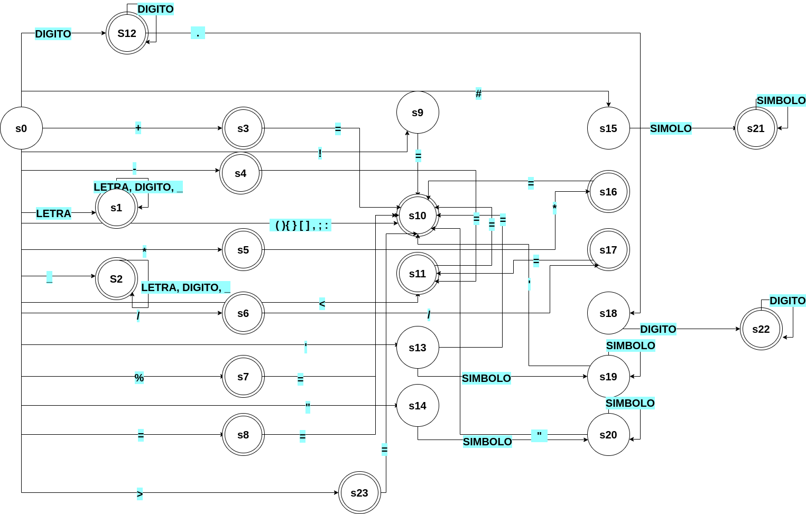

**Diagrama del método del árbol:** A continuación se presenta el diagrama de árbol el cual representa la expresión regular general. Sin embargo, la imagen no se logra apreciar bien. En la carpeta de documentación se dejará la imagen en formato png.



**Diagrama de clases:** para apreciar mejor el diagrama de clases en la carpeta de documentación se ha guardado una imagen en formato png.

